Question- Create a simple application to implement a simple calculator in android

Answer- **activity_main.xml-**

*<?***xml version="1.0" encoding="utf-8"***?>*

<**RelativeLayout xmlns:android="http://schemas.android.com/apk/res/android" xmlns:tools="http://schemas.android.com/tools" android:id="@+id/relative1" android:layout_width="match_parent" android:layout_height="match_parent" tools:context=".MainActivity"**>

<**EditText**

**android:id="@+id/edt1" android:layout_width="match_parent" android:layout_height="wrap_content" tools:ignore="SpeakableTextPresentCheck"** />

<**Button**

**android:id="@+id/button1" style="?android:attr/buttonStyleSmall" android:layout_width="wrap_content" android:layout_height="wrap_content" android:layout_alignEnd="@+id/button4" android:layout_alignRight="@+id/button4" android:layout_below="@+id/edt1" android:layout_marginTop="94dp" android:text="1"** />

<**Button**

**android:id="@+id/button2" style="?android:attr/buttonStyleSmall" android:layout_width="wrap_content" android:layout_height="wrap_content" android:layout_alignTop="@+id/button1" android:layout_toLeftOf="@+id/button3" android:layout_toStartOf="@+id/button3" android:text="2"** />

<**Button**

**android:id="@+id/button3" style="?android:attr/buttonStyleSmall" android:layout_width="wrap_content" android:layout_height="wrap_content" android:layout_alignTop="@+id/button2" android:layout_centerHorizontal="true" android:text="3"** />

<**Button**

**android:id="@+id/button4" style="?android:attr/buttonStyleSmall" android:layout_width="wrap_content" android:layout_height="wrap_content" android:layout_below="@+id/button1" android:layout_toLeftOf="@+id/button2" android:text="4"** />

<**Button**

**android:id="@+id/button5" style="?android:attr/buttonStyleSmall" android:layout_width="wrap_content" android:layout_height="wrap_content" android:layout_alignBottom="@+id/button4" android:layout_alignLeft="@+id/button2" android:layout_alignStart="@+id/button2" android:text="5"** />

<**Button**

**android:id="@+id/button6" style="?android:attr/buttonStyleSmall" android:layout_width="wrap_content" android:layout_height="wrap_content" android:layout_alignLeft="@+id/button3" android:layout_alignStart="@+id/button3" android:layout_below="@+id/button3" android:text="6"** />

<**Button**

**android:id="@+id/button7" style="?android:attr/buttonStyleSmall" android:layout_width="wrap_content" android:layout_height="wrap_content" android:layout_below="@+id/button4" android:layout_toLeftOf="@+id/button2" android:text="7"** />

<**Button**

**android:id="@+id/button8" style="?android:attr/buttonStyleSmall" android:layout_width="wrap_content" android:layout_height="wrap_content" android:layout_alignLeft="@+id/button5" android:layout_alignStart="@+id/button5" android:layout_below="@+id/button5" android:text="8"** />

<**Button**

**android:id="@+id/button9" style="?android:attr/buttonStyleSmall" android:layout_width="wrap_content" android:layout_height="wrap_content" android:layout_alignLeft="@+id/button6" android:layout_alignStart="@+id/button6" android:layout_below="@+id/button6" android:text="9"** />

<**Button**

**android:id="@+id/buttonadd" style="?android:attr/buttonStyleSmall" android:layout_width="wrap_content" android:layout_height="wrap_content" android:layout_alignEnd="@+id/edt1" android:layout_alignRight="@+id/edt1" android:layout_alignTop="@+id/button3" android:layout_marginLeft="46dp" android:layout_marginStart="46dp" android:layout_toRightOf="@+id/button3" android:text="+"** />

<**Button**

**android:id="@+id/buttonsub" style="?android:attr/buttonStyleSmall" android:layout_width="wrap_content" android:layout_height="wrap_content" android:layout_alignEnd="@+id/buttonadd" android:layout_alignLeft="@+id/buttonadd" android:layout_alignRight="@+id/buttonadd" android:layout_alignStart="@+id/buttonadd" android:layout_below="@+id/buttonadd" android:text="-"** />

<**Button**

**android:id="@+id/buttonmul" style="?android:attr/buttonStyleSmall" android:layout_width="wrap_content" android:layout_height="wrap_content" android:layout_alignLeft="@+id/buttonsub" android:layout_alignParentEnd="true" android:layout_alignParentRight="true" android:layout_alignStart="@+id/buttonsub" android:layout_below="@+id/buttonsub" android:text="*"** />

<**Button**

**android:id="@+id/button10" style="?android:attr/buttonStyleSmall" android:layout_width="wrap_content" android:layout_height="wrap_content" android:layout_below="@+id/button7" android:layout_toLeftOf="@+id/button2" android:text="."** />

<**Button**

**android:id="@+id/button0" style="?android:attr/buttonStyleSmall" android:layout_width="wrap_content" android:layout_height="wrap_content" android:layout_alignLeft="@+id/button8" android:layout_alignStart="@+id/button8" android:layout_below="@+id/button8" android:text="0"** />

<**Button**

**android:id="@+id/buttonC" style="?android:attr/buttonStyleSmall" android:layout_width="wrap_content" android:layout_height="wrap_content" android:layout_alignLeft="@+id/button9" android:layout_alignStart="@+id/button9" android:layout_below="@+id/button9" android:text="C"** />

<**Button**

**android:id="@+id/buttondiv" style="?android:attr/buttonStyleSmall" android:layout_width="wrap_content" android:layout_height="wrap_content" android:layout_alignEnd="@+id/buttonmul" android:layout_alignLeft="@+id/buttonmul" android:layout_alignRight="@+id/buttonmul" android:layout_alignStart="@+id/buttonmul" android:layout_below="@+id/buttonmul" android:text="/"** />

<**Button**

**android:id="@+id/buttoneql" android:layout_width="wrap_content" android:layout_height="wrap_content" android:layout_alignEnd="@+id/buttondiv" android:layout_alignLeft="@+id/button10" android:layout_alignRight="@+id/buttondiv" android:layout_alignStart="@+id/button10" android:layout_below="@+id/button0" android:layout_marginTop="37dp" android:text="="** />

</**RelativeLayout**>

# MainActivity.java-

**package** com.example.calculator;

**import** androidx.appcompat.app.AppCompatActivity; **import** android.os.Bundle; **import** android.view.View; **import** android.widget.Button; **import** android.widget.EditText;

**public class** MainActivity **extends** AppCompatActivity {

Button **button0**, **button1**, **button2**, **button3**, **button4**, **button5**, **button6**, **button7**, **button8**, **button9**, **buttonAdd**, **buttonSub**, **buttonDivision**,

**buttonMul**, **button10**, **buttonC**, **buttonEqual**;

EditText **crunchifyEditText**;

**float mValueOne**, **mValueTwo**;

**boolean crunchifyAddition**, **mSubtract**, **crunchifyMultiplication**, **crunchifyDivision**;

@Override

**protected void** onCreate(Bundle savedInstanceState) { **super**.onCreate(savedInstanceState); setContentView(R.layout.***activity_main***);

**button0** = (Button) findViewById(R.id.***button0***); **button1** = (Button) findViewById(R.id.***button1***); **button2** = (Button) findViewById(R.id.***button2***); **button3** = (Button) findViewById(R.id.***button3***); **button4** = (Button) findViewById(R.id.***button4***); **button5** = (Button) findViewById(R.id.***button5***); **button6** = (Button) findViewById(R.id.***button6***); **button7** = (Button) findViewById(R.id.***button7***); **button8** = (Button) findViewById(R.id.***button8***); **button9** = (Button) findViewById(R.id.***button9***); **button10** = (Button) findViewById(R.id.***button10***); **buttonAdd** = (Button) findViewById(R.id.***buttonadd***); **buttonSub** = (Button) findViewById(R.id.***buttonsub***); **buttonMul** = (Button) findViewById(R.id.***buttonmul***); **buttonDivision** = (Button) findViewById(R.id.***buttondiv***); **buttonC** = (Button) findViewById(R.id.***buttonC***); **buttonEqual** = (Button) findViewById(R.id.***buttoneql***); **crunchifyEditText** = (EditText) findViewById(R.id.***edt1***);

**button1**.setOnClickListener(**new** View.OnClickListener() {

@Override

**public void** onClick(View v) {

**crunchifyEditText**.setText(**crunchifyEditText**.getText() +

**"1"**);

}

});

**button2**.setOnClickListener(**new** View.OnClickListener() {

@Override

**public void** onClick(View v) {

**crunchifyEditText**.setText(**crunchifyEditText**.getText() +

**"2"**);

}

});

**button3**.setOnClickListener(**new** View.OnClickListener() {

@Override

**public void** onClick(View v) {

**crunchifyEditText**.setText(**crunchifyEditText**.getText() +

**"3"**);

}

});

**button4**.setOnClickListener(**new** View.OnClickListener() {

@Override

**public void** onClick(View v) {

**crunchifyEditText**.setText(**crunchifyEditText**.getText() +

**"4"**);

}

});

**button5**.setOnClickListener(**new** View.OnClickListener() {

@Override

**public void** onClick(View v) {

**crunchifyEditText**.setText(**crunchifyEditText**.getText() +

**"5"**);

}

});

**button6**.setOnClickListener(**new** View.OnClickListener() {

@Override

**public void** onClick(View v) {

**crunchifyEditText**.setText(**crunchifyEditText**.getText() +

**"6"**);

}

});

**button7**.setOnClickListener(**new** View.OnClickListener() {

@Override

**public void** onClick(View v) {

**crunchifyEditText**.setText(**crunchifyEditText**.getText() +

**"7"**);

}

});

**button8**.setOnClickListener(**new** View.OnClickListener() {

@Override

**public void** onClick(View v) {

**crunchifyEditText**.setText(**crunchifyEditText**.getText() +

**"8"**);

}

});

**button9**.setOnClickListener(**new** View.OnClickListener() {

@Override

**public void** onClick(View v) { **crunchifyEditText**.setText(**crunchifyEditText**.getText() +

**"9"**);

}

});

**button0**.setOnClickListener(**new** View.OnClickListener() {

@Override

**public void** onClick(View v) { **crunchifyEditText**.setText(**crunchifyEditText**.getText() +

**"0"**);

}

});

**buttonAdd**.setOnClickListener(**new** View.OnClickListener() {

@Override

**public void** onClick(View v) {

**if** (**crunchifyEditText** == **null**) { **crunchifyEditText**.setText(**""**);

} **else** { **mValueOne** = Float.*parseFloat*(**crunchifyEditText**.getText() + **""**); **crunchifyAddition** = **true**; **crunchifyEditText**.setText(**null**);

}

}

});

**buttonSub**.setOnClickListener(**new** View.OnClickListener() {

@Override

**public void** onClick(View v) {

**mValueOne** = Float.*parseFloat*(**crunchifyEditText**.getText() +

**""**);

**mSubtract** = **true**;

**crunchifyEditText**.setText(**null**);

}

});

**buttonMul**.setOnClickListener(**new** View.OnClickListener() {

@Override

**public void** onClick(View v) {

**mValueOne** = Float.*parseFloat*(**crunchifyEditText**.getText() +

**""**);

**crunchifyMultiplication** = **true**; **crunchifyEditText**.setText(**null**);

}

});

**buttonDivision**.setOnClickListener(**new** View.OnClickListener() {

@Override

**public void** onClick(View v) {

**mValueOne** = Float.*parseFloat*(**crunchifyEditText**.getText() +

**""**);

**crunchifyDivision** = **true**; **crunchifyEditText**.setText(**null**);

}

});

**buttonEqual**.setOnClickListener(**new** View.OnClickListener() {

@Override

**public void** onClick(View v) {

**mValueTwo** = Float.*parseFloat*(**crunchifyEditText**.getText() + **""**);

**if** (**crunchifyAddition** == **true**) {

**crunchifyEditText**.setText(**mValueOne** + **mValueTwo** + **""**); **crunchifyAddition** = **false**;

}

**if** (**mSubtract** == **true**) {

**crunchifyEditText**.setText(**mValueOne** - **mValueTwo** + **""**); **mSubtract** = **false**;

}

**if** (**crunchifyMultiplication** == **true**) {

**crunchifyEditText**.setText(**mValueOne** * **mValueTwo** + **""**); **crunchifyMultiplication** = **false**;

}

**if** (**crunchifyDivision** == **true**) {

**crunchifyEditText**.setText(**mValueOne** / **mValueTwo** + **""**); **crunchifyDivision** = **false**;

}

}

});

**buttonC**.setOnClickListener(**new** View.OnClickListener() {

@Override

**public void** onClick(View v) { **crunchifyEditText**.setText(**""**);

}

});

**button10**.setOnClickListener(**new** View.OnClickListener() {

@Override

**public void** onClick(View v) {

**crunchifyEditText**.setText(**crunchifyEditText**.getText() +

**"."**);

}

});

} }

# Output-

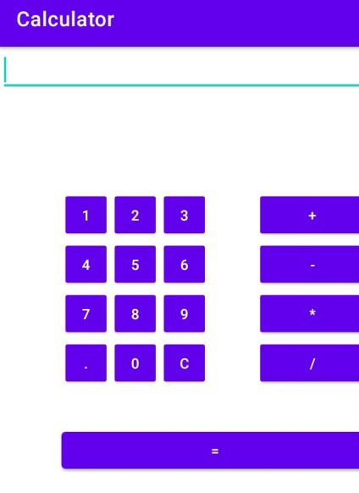

# Example-

# Output for 4+4:

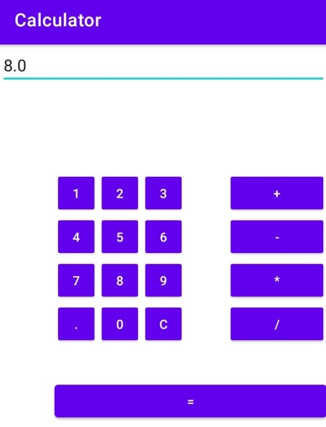

# And so on……..